Contents

New API Logging SE9 2

Introduce 2

Use Logger Default Work 2

Use Extenal Logging Framwork [Log4j2] 3

Custom Framworks implement use SLF4J 4

Create Logging implement System 5

Add into moudule-infor.java 6

Ok Run Done 7

Link My Project: 7

Reference 9

# New API Logging SE9

## Introduce

This API has been introduced in java to provide a common mechanism to handle all the platform logs and to expose a service interface that can be customized by libraries and applications. This way, the JDK platform logs can use the same logging framework as the application, and the project dependencies can be reduced.

# Use Logger Default Work

Simple demo with print log into Consolog

Create Logger inplement the System.Logger

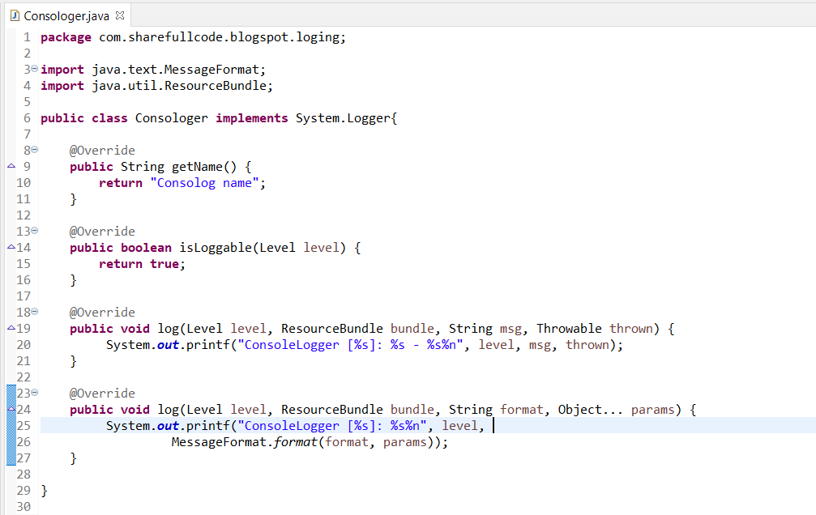

We need to implement a LoggerFinder that creates instances of our Consologer.

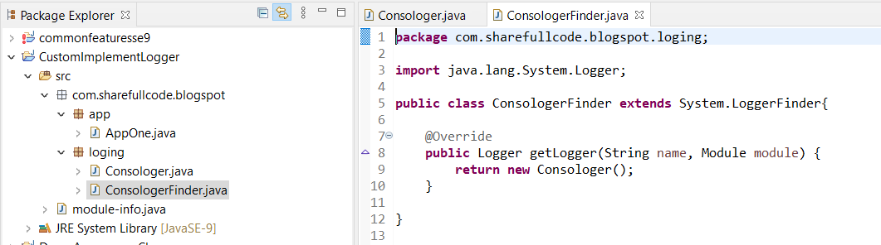

Finally, we need to register out LoggerFinder as a Service so it can be discovered by JDK. If we don’t provide an implementation, the SimpleConsoleLogger will be used by default.

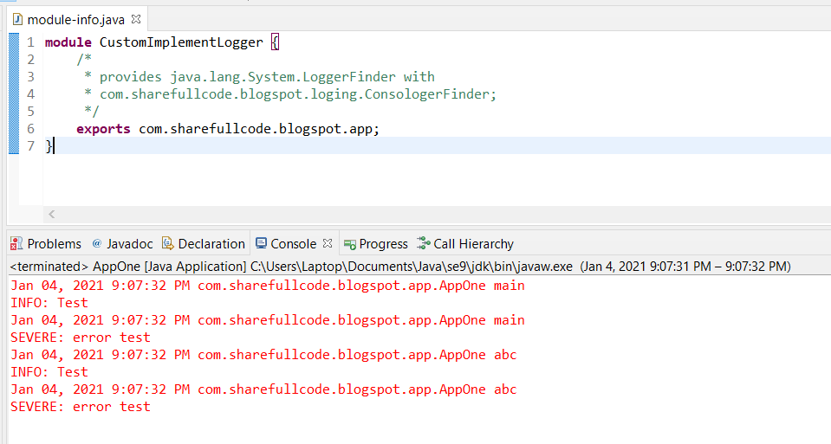

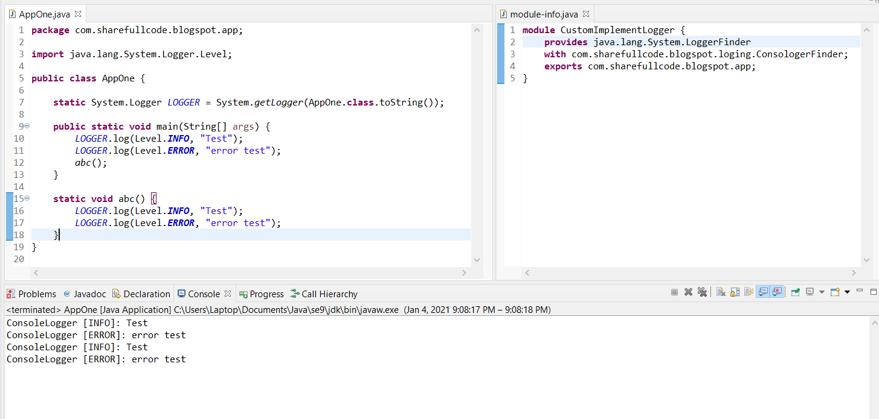

# Use Extenal Logging Framwork [Log4j2]

One of the most useful uses of the Logging API in java 9 is to let applications route the JDK logs to the same logging framework the application is using.

## Custom Framworks implement use SLF4J

https://examples.javacodegeeks.com/enterprise-java/slf4j/slf4j-tutorial-beginners/

Add File pom.xml

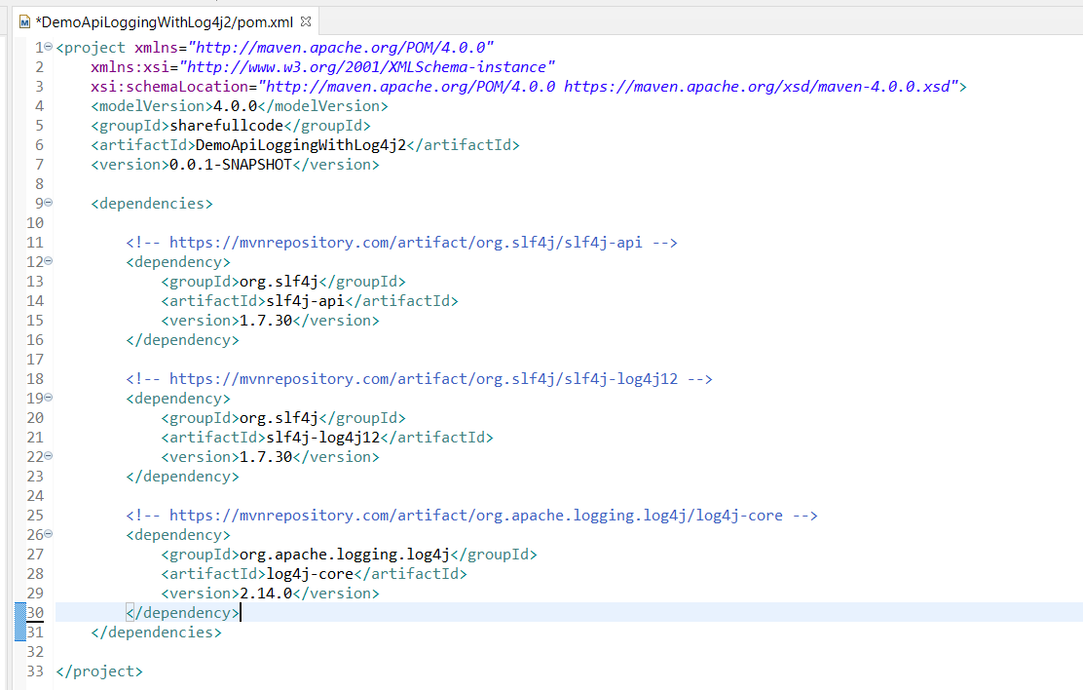

## Create Logging implement System

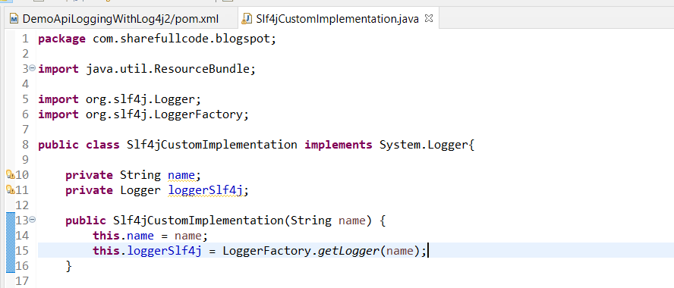

The method remain is implement

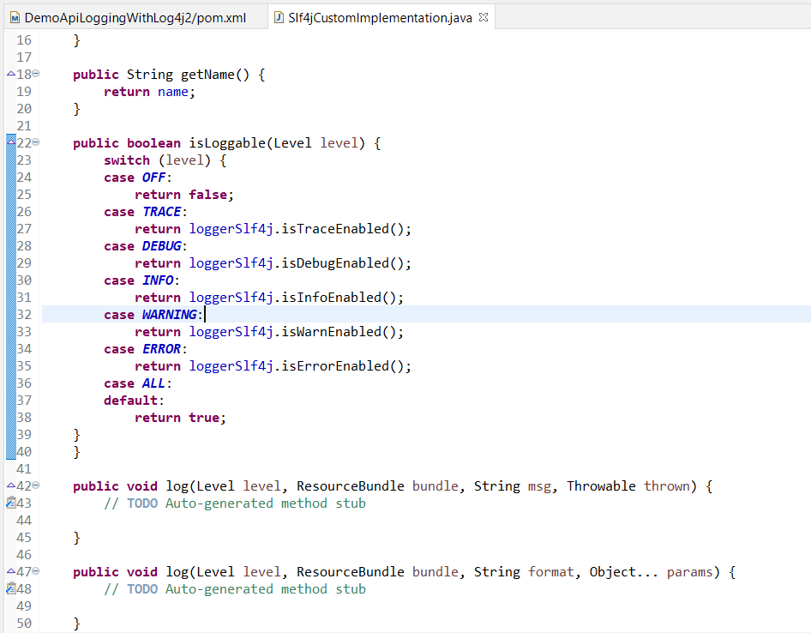

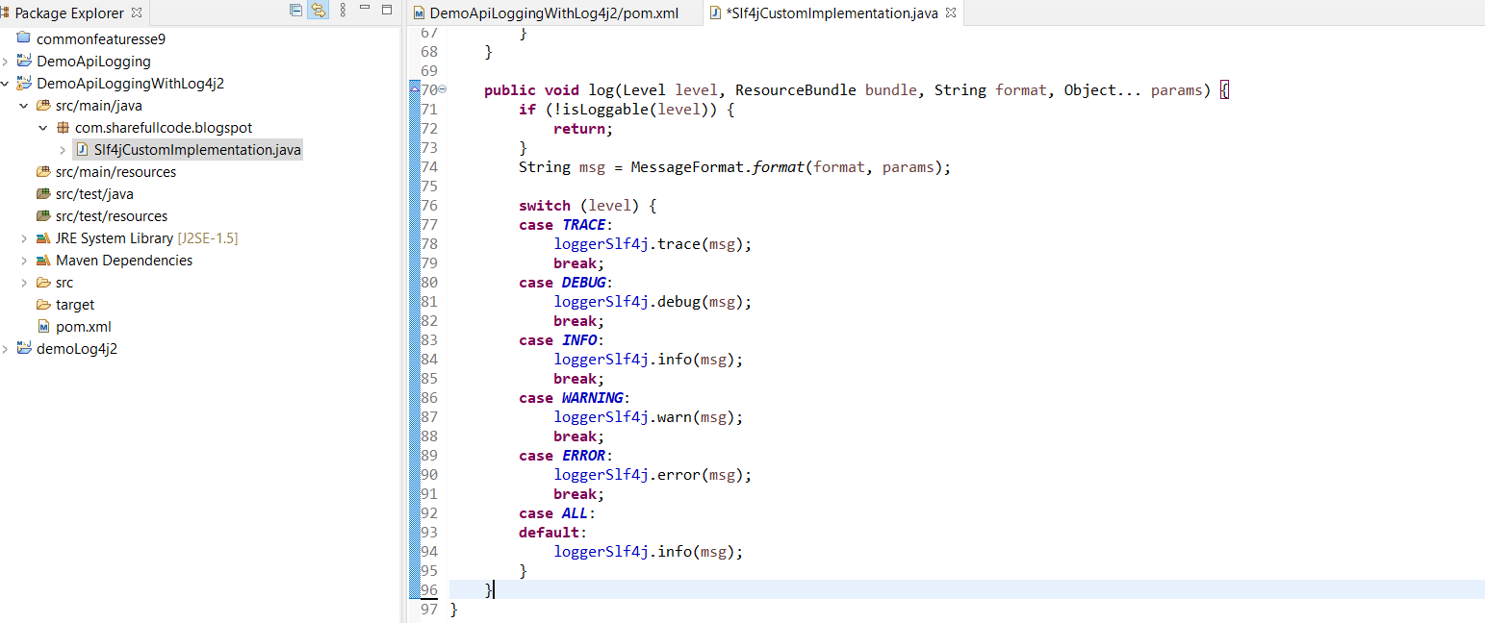

Create System.FinderLogger

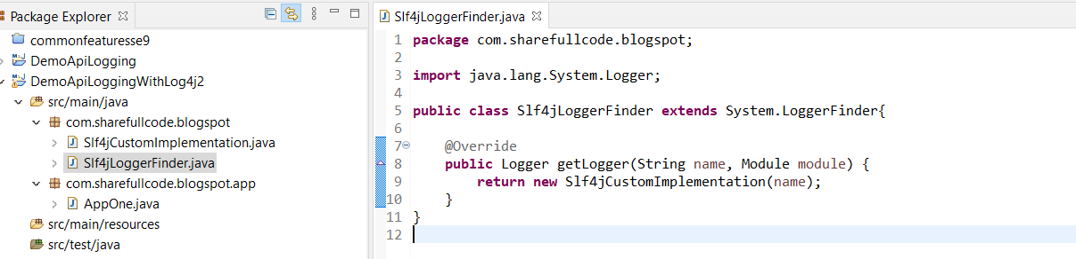

## Add into moudule-infor.java

provides … with … Register service in the module-info

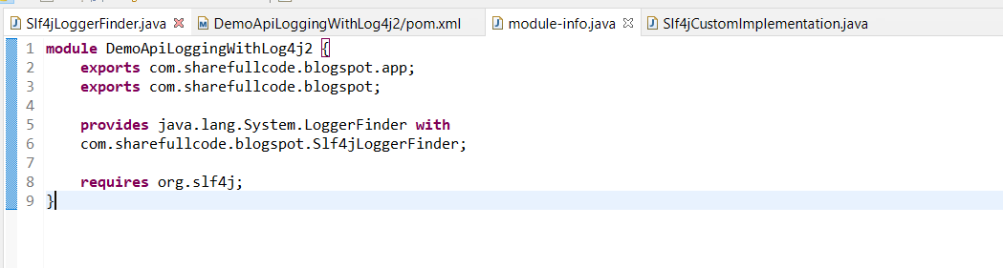

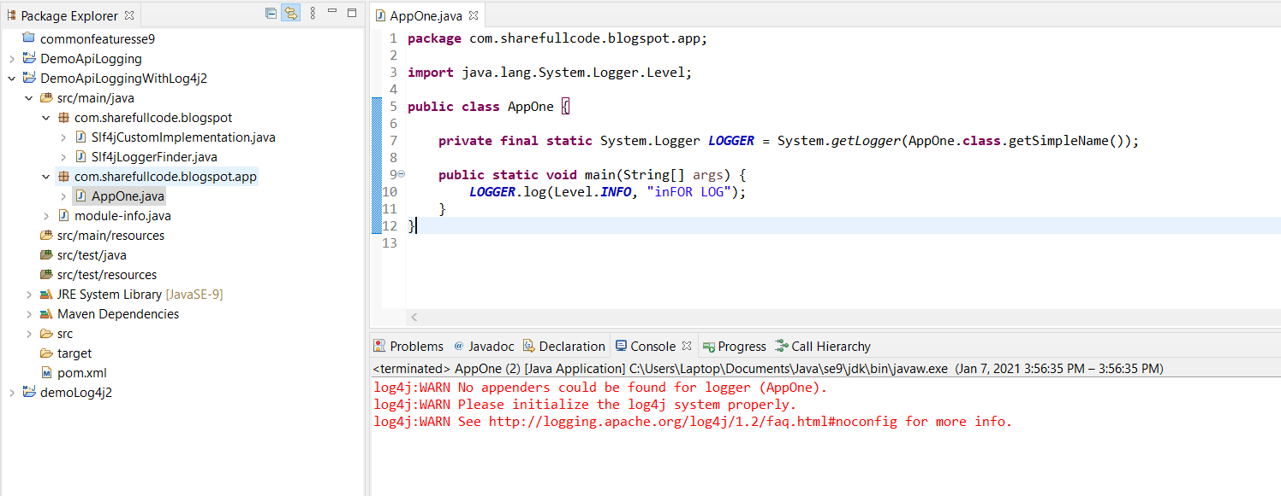

Not yet create file log4j config

Src/resources/Log4j.properties

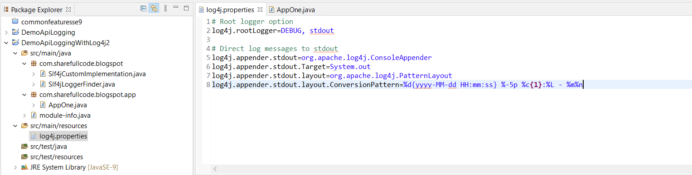

## Ok Run Done

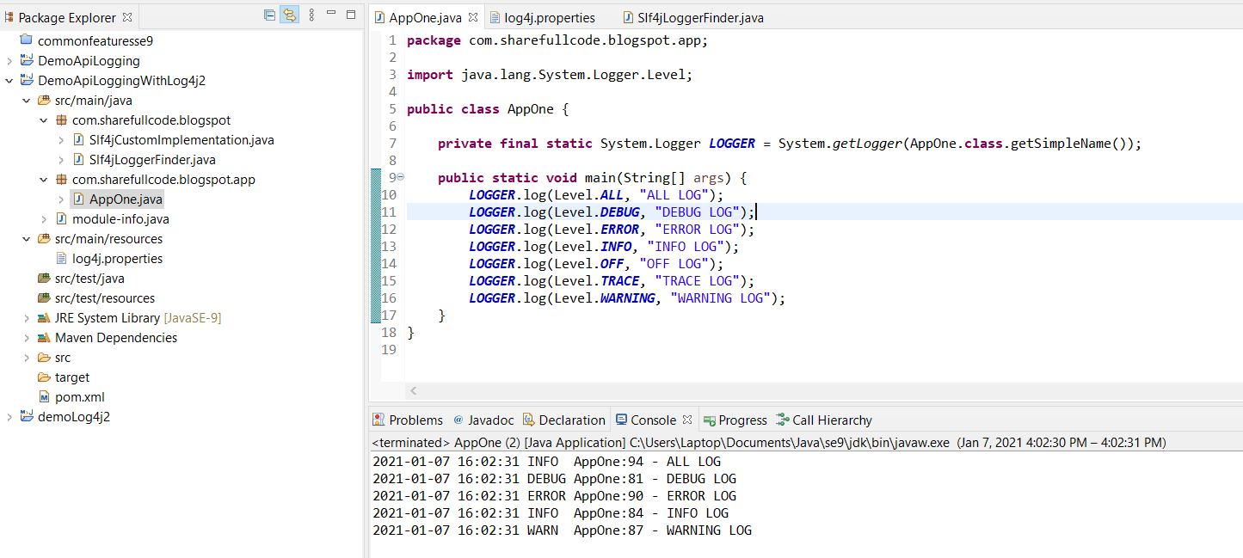

Link My Project: <https://github.com/nguyenthinhit996/sharefullcode/tree/java/Learn%20Java/NewFeatureSE9/API%20Logging>

# Reference

**This section is non commercial mainly sharing and advance knowlage for java.This tutorials has referenced document from the list below if you has complain for license, i will remove all from internet. Thank you all everything.**

<https://www.baeldung.com/java-9-logging-api>

<https://examples.javacodegeeks.com/enterprise-java/slf4j/slf4j-tutorial-beginners/>